RESEARCH, Meeting with historians/enthusiasts:

* Meeting scheduled with museum researcher
* Meeting with external heritage expert, Pennoyer’s, <https://www.pennoyers.org.uk/history.html>
* Visit to RAF Hendon to take reference images of R33/speak with historians

 DESIGN:

* UI Content, functionality
  + - UI layout, persistent banners
    - UI layout, collection screen
    - UI layout, information screen
    - UI layout, camera screen
    - UI layout, settings menu
    - UI layout, help screen
* UI/screen transitions
* Splash screen
* Credits screen
* Help screen
  + - Animated gifs to convey app function without words
  + R34 summary screen
    - Summarised narrative of voyage and relevant pictures for inclusion
* Event narrative (9)
  + - Provide specific details of events related to each object
* Event AR effects (7)
  + - Visuals to highlight each AR object
    - Give everything context: support for floating floors, people etc come out of poster/are viewed within poster, shader to hide things outside of visible box
* Posters
  + - Advertising app with QR code to app store
    - Event triggers 1-9
  + Cards
    - Event triggers 1-9
    - Advertising app and linking to dev blog
  + 3D models

3D ASSETS:

R34 complete textures model

Gondola model and texture

Propeller particle effects

Wind particle effects

Modelled crew members and texture.

4 uniform variations and textures (to represent selection of crew).

Variation of clothing and clothing texture applied to crew 3D model (to represent stowaway).

Modified crew model (clothing) and retexture (to represent the Major).

Parachute for Major to descend.

Airship model with texture, animated to land in the field below

Field model with texture

Crude human models with simple textures to populate field

MarkV tank with texture

Smoke particle effects for the tank exhaust.

Tank crew with textures

2D ASSETS:

Sprites and animation showing user using the device camera to trigger AR effects

Cat sprite, 9 variations of cat sprite (cat costumes) to accompany each event.

Animation of cat sprite (eye blink, tail wag)

Unity animations for help screen (simple outlines of objects)

* Hand, holding phone: moving to a position where poster would become visible
* Static rectangle (poster)
* Animated effect to represent AR recognition
* Animation of airship rotating on phone screen
* Animation moving phone away from poster, nothing occurring on phone screen
* Pulsating camera icon
* Pulsating panel outline

2D ASSETS – UI Icons

Camera

Collection

Help

Settings

“the R34”

Settings Cog

Settings Background

Audio

Battery

Hamburger

Generic button (soft corners)

AUDIO ASSETS:

Engine

Wind

Rain

Thunder

Crowd cheering/excitement

Distant airship engine

PROGRAMMING:

**UI**

* AR ID script
  + Functionality to make unique posters trigger unlock events in chronological order
  + Corresponding collection panel unlock
  + Contextual camera button, viewfinder
* Button functions
  + Toggle deactivation/activation of buttons/animations depending on scene
* UI panel animations
* Burger menu
* Settings menu
* Audio menu
  + Scene transitions & animations
  + Toggle 3D on off
  + Toggle audio on off
* Animations
  + Collection menu to information screen
  + Help screen animations
  + Cat animations
  + Side menu animations
  + Setting animations
* At app start introduction to app by cat
* Cat dialogue to update to relevant information when an object trigger is found
* Cat dialogue to default to relevant help information if an object has not been found recently
* Cat mascot to change appearance based on user selection
* In collection screen, update scale of selected event object depending on relative position
* In collection screen, horizontally scrollable event objects
* Scrollable text box beneath image of info screen
* Vuforia image database creation for each trigger material produced (18)
  + 8, event posters
  + 8, event cards
  + 1 app promotional poster
  + 1 promotional card
* Vuforia image recognition
* On corresponding trigger detection, make button to information screen selectable. Also make object selectable in collection screen
* Scrollable information boxes
* Scrollable information box for R34 screen, effect change in information screen image

**INTERACTIONS**, **9 Events:**

**1, Cat (mascot).**

* *Cat exists as its own event. The cat will serve as a guide within the app – assisting new users with navigation of the app and giving additional information on triggering of other AR objects.*
* Assets needed:
* Audio (cat meow, purr)
* 2D cat sprite.
* Simple cat idle animations
* Description and narrative of the cats ‘role’ in the voyage to be displayed on the info panel.
* 9 cat sprites must be produced, one of the cat itself and 8 sprites of the cat in costumes corresponding to the other 8 events.

**2, R34 Take-off**

* *Airship will be displayed in Hangar, airship will be animated to give appearance of slight bobbing in wind currents.*
* Assets needed:
  + 3D airship model and texture
  + 3D Hangar and texture
  + Screenshot of the AR model for display in the info panel.
  + Description of the airships takeoff and crews boarding to be displayed on the info panel.

**3, Gondola**

* *Gondola model will be displayed beneath airship model. The airship model will fade becoming invisible, perspective will focus and zoom toward the gondola. Once the airship is not visible and the camera focused on the gondola, particle effects representing wind and thrust generated by the propellers will play. Users will be able to rotate the gondola model to inspect freely from any angle.*
* Assets needed:
  + 3D gondola model and texture
  + Propeller particle effects
  + Wind particle effects
* Audio:
  + Engine sound
  + Wind sound
* Screenshot of the AR model for display in the info panel.
* Description of the airships gondolas to be displayed on the info panel.

**4, Crew**

* *Selected members of the crew will be displayed as 3D models, standing inset within the trigger poster.*
* Assets needed:
  + 3D modelled crew members and texture.
  + 4 uniform variations and textures.
  + Screenshot of the AR model for display in the info panel.
* Description of the airships crew members to be displayed on the info panel.

**5, Stowaway**

* *Model of the stowaway will be shown, inset within the trigger material. In the information screen of the model the 2D, when the story describes the stowaway being put to work as a cook, the main displayed image will transition to reflect his new attire.*
* Assets needed:
  + - Variation of clothing and clothing texture applied to crew 3D model.
* Screenshot of the AR model for display in the info panel.
* Description and narrative of the stowaway’s experience to be displayed on the info panel.

**6, Inclement Conditions**

* + *3D airship will be displayed over a section of the Atlantic Ocean. Dark clouds, rain, thunder, heavy wind effects will be displayed.*
  + Assets needed:
    - R34 model
    - Particle effects for wind, rain, cloud, lightning (light flash)
    - Audio effects for wind, rain, thunder, engine sounds.
  + Screenshot of the AR model for display in the info panel.
  + Description and narrative of the events during the storm to be displayed on the info panel.

**7, Major**

* *3D crew model will be displayed, textured with the Majors uniform. The major will be hanging from his deployed parachute. The model will be animated to appear to be swinging in the wind while he descends. Empty game objects with trail renderers will be animated to provide ‘wind lines’ adding to the effect.*
* Assets needed:
* Modified crew model (clothing) and retexture.
* Screenshot of the AR model for display in the info panel.
* Description and narrative of the Majors parachute descent to be displayed on the info panel.

**8, NY landing**

* *The airship will descend to the field below to land. Americans will be in the field to assist with the landing following the parachute jump of the Major.*
* Assets needed:
  + 3D airship model with texture, animated to land in the field below
  + 3D field model with texture
  + Crude human models with simple textures to populate field
* Audio assets:
  + Crowd cheering/excitement
* Screenshot of the AR model for display in the info panel.
* Description and narrative of the American’s assistance to help land the airship to be displayed on the info panel.

**9, Pulham Homecoming**

* *The airship will be shown over England having made the return leg of the journey, markV tank in the foreground with tank crew atop (as in picture from 1919).*
* Assets needed:
  + 3D airship with texture
  + 3D MarkV tank with texture
  + Smoke particle effects for the tank exhaust.
  + 3D tank crew with textures
  + The picture from 1919 for display in the info panel.
* Audio assets needed:
  + Cheering
  + Distant airship engine sound
* Description and narrative of the airships return journey to be displayed on the info panel.

**Main screens**

**Collection screen, expanded Burger menu**

**Collection Screen**

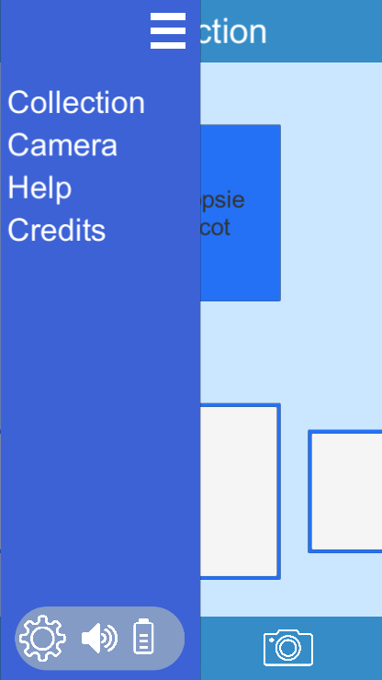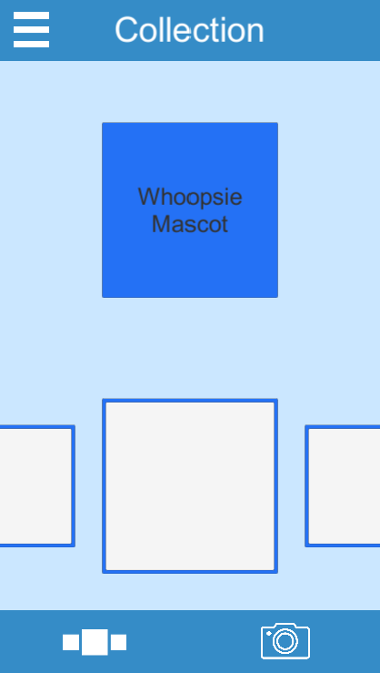

**Information Screen**

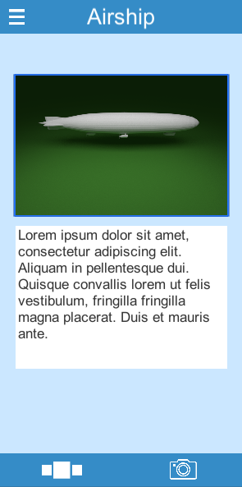

**Camera Screen**

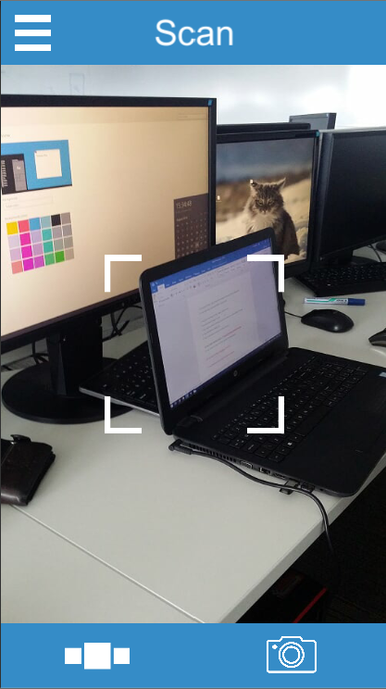

**Screen transitions**

**User Opens App**

**Credits screen**

Accessible from side menu

**Splash Screen**

**Information Screen**

**Collection Screen**

**Help Screen**

When help screen is closed app returns to previous screen.

**Camera Screen**

**Collection screen**

**Camera Button**

Persistent throughout application.

Takes user to the AR camera.

**Collection Button**

Persistent throughout application.

Takes user to the collection screen.

**Screen Heading**

Persistent throughout application.

Title of current screen.



**Cat mascot**

Present on collection screen.

Provides brief explanation of currently selected object.

Alternatively provides instructional help to users.

**Scroll Menu**

AR events, 1-9, Left to right.

Tiles increase in scale the closer to centre screen.

If selected user is taken to corresponding information screen.

**Camera screen**

**‘Look for’ icon**

Shown to the user if all AR triggers have not been discovered.

Encourages user to location AR triggers in chronological order.



**Look for:**

**Information screen**



**Screen Heading**

Changes to the name of the current object

**Object view window**

Appears in 3D if battery saver off.

User will be able to view model and overlaid effects. Swipe to spin model, viewing from different angles.

Appears in 2D if battery saver on.

**Object description**

Short narrative, explanation and description of the object and its relevance.

**Burger Menu**

**Burger menu**

Persistent throughout application.

Menu slides out from screen left



**Help button**

Selecting the help button closes the burger menu and

Takes the user to a screen showing simple 2D animations describing how to use the app.

**Settings menu**

Menu slides to right from settings cog icon

**Battery Saver**

Toggles battery saver on/off.

If toggled off, information screens show 3D models.

If toggled on, information screens show 2D images.

The AR camera will always trigger 3D AR models on detection of trigger material, regardless of battery setting.

**Audio Menu**

Tapping the speaker icon will toggle audio on/off.



**Task List**

**Visual Assets**

**3D**

R34 textured model

Gondola model and texture

Propeller particle effects

Wind particle effects

Modelled crew members and texture.

4 uniforms and textures.

Variation of clothing and clothing texture applied to crew 3D model (to represent stowaway).

Modified crew model (clothing) and retexture (to represent the Major).

Parachute for Major to descend.

Crude human models with simple textures to populate field

MarkV tank with texture

Smoke particle effects for the tank exhaust.

Crude silhouette models for tank crew

**2D**

Sprites and animation showing user using the device camera to trigger AR effects

Cat sprite, 9 variations of cat sprite (cat costumes) to accompany each event.

Animation of cat sprite (eye blink, tail wag)

Tank image from 1919 for display in the info panel.

**Programming Tasks (JIRA TRACKABLE)**

**UI**

* Collection button
  + On press, set collection screen active, set all others inactive
* Camera button
  + On press, set camera screen active, set all others inactive
* Burger menu
  + On press, expand menu from screen left (sliding animation)
  + If open, on press, collapse menu to screen left (sliding animation)
* The R34 button (within burger menu)
  + On press, enables the ‘about the R34 screen’, disables all others
* Settings menu (within burger menu)
  + On oppress, expand menu from cog icon vertically (sliding animation)
  + If open, on press, collapse menu to cog icon (sliding animation)
* Audio menu (within burger menu)
  + On press, toggle all app audio enabled/disabled
  + If audio is enabled in app, show audio slider vertically from audio icon
* Battery saver (within burger menu)
  + On press, toggle 3D artwork/disable 3D artwork and replace with 2D artwork
* Collection button (within burger menu)
  + On press, set collection screen active, set all others inactive
* Camera button (within burger menu)
  + On press, set camera screen active, set all others inactive
* Help button (within burger menu)
  + On press, set help screen active, set all others inactive
  + Trigger display of example animations
* Credits button (within burger menu)
  + On press, set credits screen active, set all others inactive
* Button functions
  + Toggle deactivation/activation of buttons/animations depending on scene
* UI panel animations
* Burger menu
* Settings menu
* Audio menu
  + Scene transitions
  + Toggle 3D on off
  + Toggle audio on off
  + Set volume through audio slider
* At app start introduction to app by cat
* Cat dialogue to update to relevant information when an object trigger is found
* Cat dialogue to default to relevant help information if an object has not been found recently
* In collection screen, update scale of selected event object depending on relative position
* In collection screen, horizontally scrollable event objects
* Scrollable text box beneath image of info screen
* Vuforia image database creation for each trigger material produced (20)
  + 9, event posters
  + 9, event cards
  + 1 app promotional poster
  + 1 promotional card
* Vuforia image recognition
* On corresponding trigger detection, make button to information screen selectable. Also make object selectable in collection screen
* On initial visit to each objects information screen, cat mascot will appear in place of description to introduce the object
* After the cats dialogue has ended in the information screen, the cat is permanently replaced by the description panel

**Stretch Goals**

Completion of these targets are not required, though if possible will enhance the effectiveness of the application:

Client was made aware stretch goals will only be considered for development should the essential elements of the project be fully completed.

Extending the use of the app beyond the duration of the weekend – basic concepts included removing portions of the AR elements and the app serving as a ‘dictionary’ of items/events when outside of the event dates.

AR interaction with the in-museum display cases - client still needs content to display for the return leg of the voyage which could be designed with AR in mind. We will need to await confirmation of the display contents to assess compatibility with AR.

Production of 3D printed models which could be sent to local schools for painting. There is then potential to explore adding AR effects/information to the models via the app. Client expressed interest in this stretch goal as it will help attract children to the event. Potential obstacles were explained to the client including model recognition not being supported on all devices and if the shape of the models is changed or distorted by too great a degree, recognition would not be possible.

Social Media Connectivity. The ability to promote the airship event, and the museum through users sharing what they have found, through use of the app, to social media platforms.

**Significant Potential Risks**

Not receiving 3D models from contributors:

* **have back-up artists (although less desired) who have confirmed they would produce assets if asked.**
* **Elliot and Tom have some familiarity with producing 3D assets, though may be less time efficient – should not be an issue given the project deadline. Neither Elliot or Tom have sufficient experience to texture models well or efficiently.**
* **2D art – if art is not provided from artists, team members are not able to produce 2D assets to the necessary quality themselves. May need to consider outsourcing professionally.**
* **Any potential issues with Vuforia licensing – client has made us aware the museum fund should accommodate any reasonable expense to ensure the project is suitable for the exhibition. If purchasing license becomes necessary due to client needs, USD499 for indefinite license, USD99 for monthly license. Client has confirmed this won’t be an issue though not formally.**